

**ELEVATE LABS  
Cyber Security Internship**

**Task 8  
Documentation Report  
Submitted by Suhaila P.S**

**VPN Setup & Privacy Test Report**

**1. Introduction**

A VPN (Virtual Private Network) encrypts your internet traffic and hides your IP address, enhancing privacy and bypassing geo-restrictions. This report documents the setup and testing of ProtonVPN’s free tier.

**2. Setup Steps**

**Step 1: Sign Up for ProtonVPN**

* Created an account at [protonvpn.com/free-vpn](https://protonvpn.com/free-vpn).

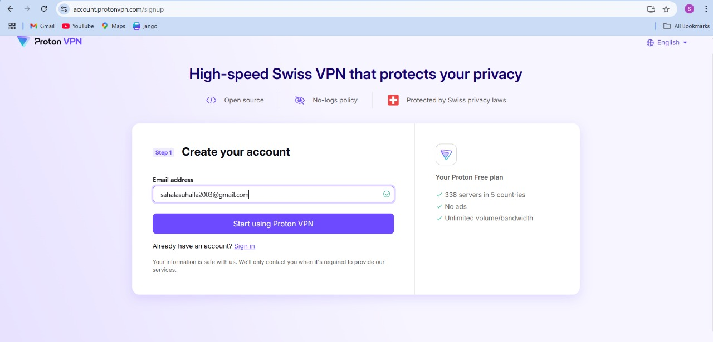

Figure 1: ProtonVPN sign up page

**Step 2: Download & Install VPN Client**

* + Downloaded/installed ProtonVPN app for Windows/macOS.

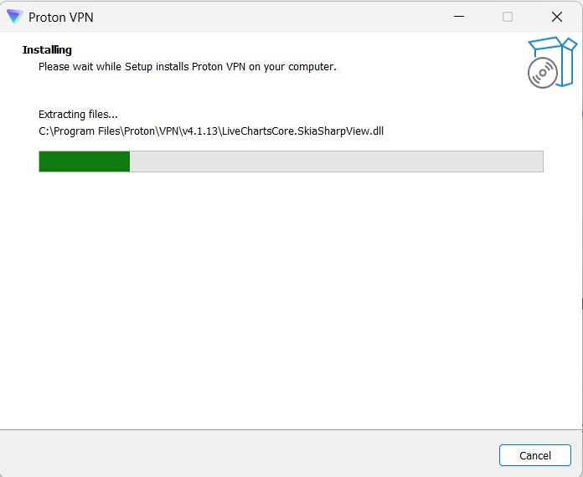

Figure 2:Installation Progress Window

**Step 3: Connect to a Server**

* Connected to **Netherlands (NL-FREE#104)** via WireGuard protocol.

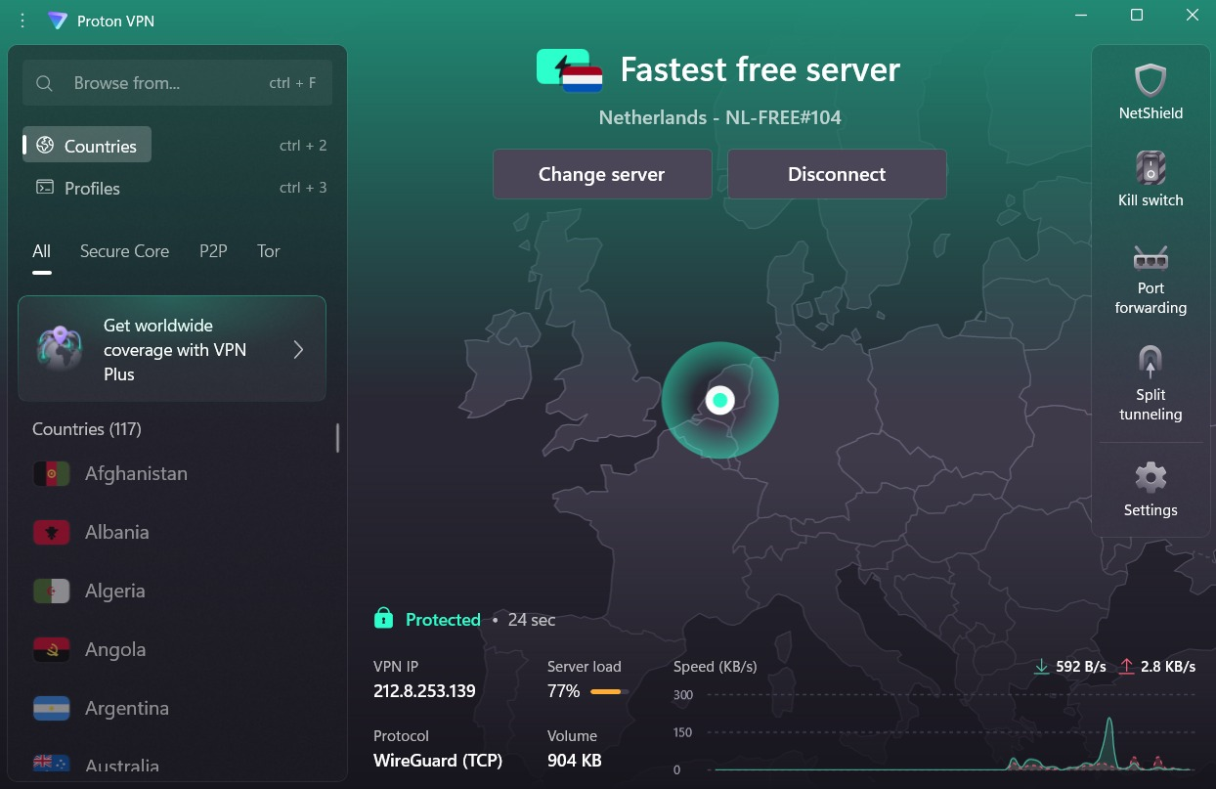

Figure 3: VPN dashboard showing "Connected" status.

**3. Verification Tests**

**Test 1: IP Address Masking**

* **Before VPN**: Real IP (43.229.89.200, India).
* **After VPN**: Masked IP (212.8.253.139, Netherlands).
* **Tools Used**: [WhatIsMyIPAddress.com](https://whatismyipaddress.com/).

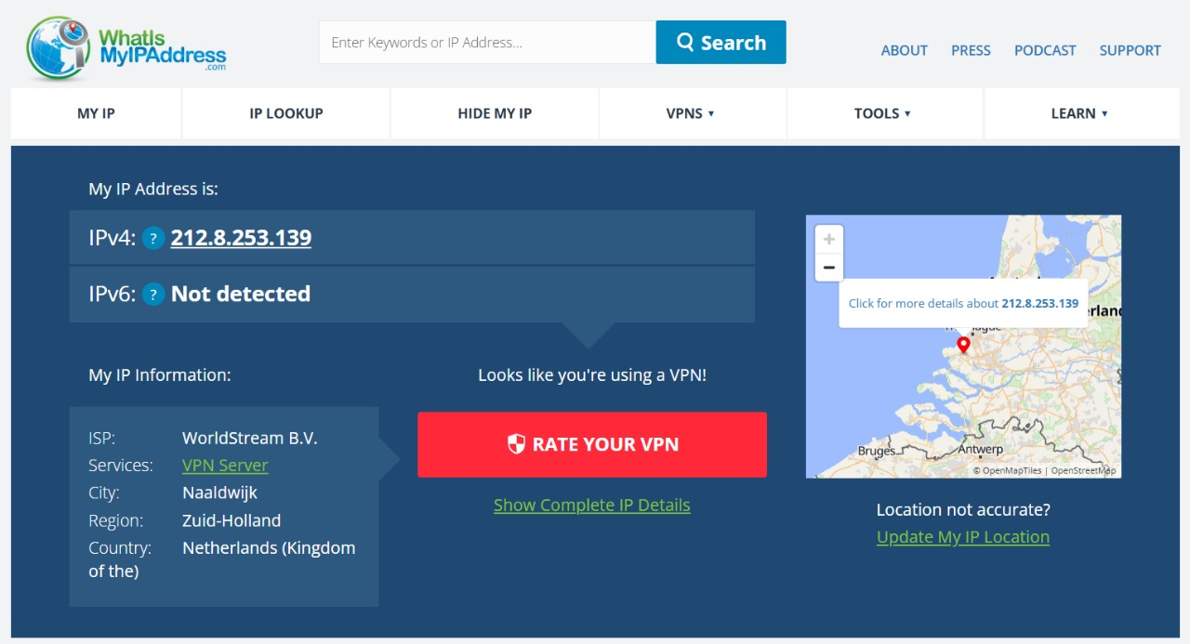

Figure 4:IP Changed

**Test 2: DNS Leak Test**

* Confirmed **no leaks**—all DNS requests routed through ProtonVPN.

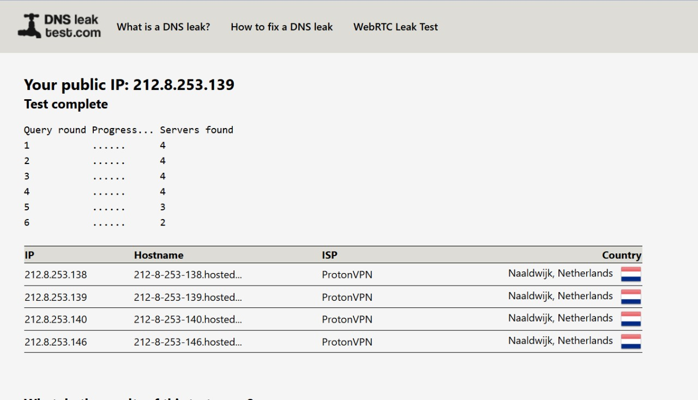

Figure 5: [DNSLeakTest.com](https://www.dnsleaktest.com/) results showing ProtonVPN servers.

**Test 3: HTTPS Encryption Check**

* Most sites (e.g., Wikipedia) showed **🔒 HTTPS**.
* **Note**: Google loaded as HTTP (no padlock) due to cached settings, but VPN encryption still active.

**4. Speed Comparison**

| **Metric** | **Without VPN** | **With VPN (Netherlands)** | **Difference** |
| --- | --- | --- | --- |
| Download Speed | 102.52 Mbps | 59.63 Mbps | ▼ 42% slower |
| Upload Speed | 99.88 Mbps | 3.65 Mbps | ▼ 96% slower |
| Ping | 7 ms | Not recorded | Higher latency |

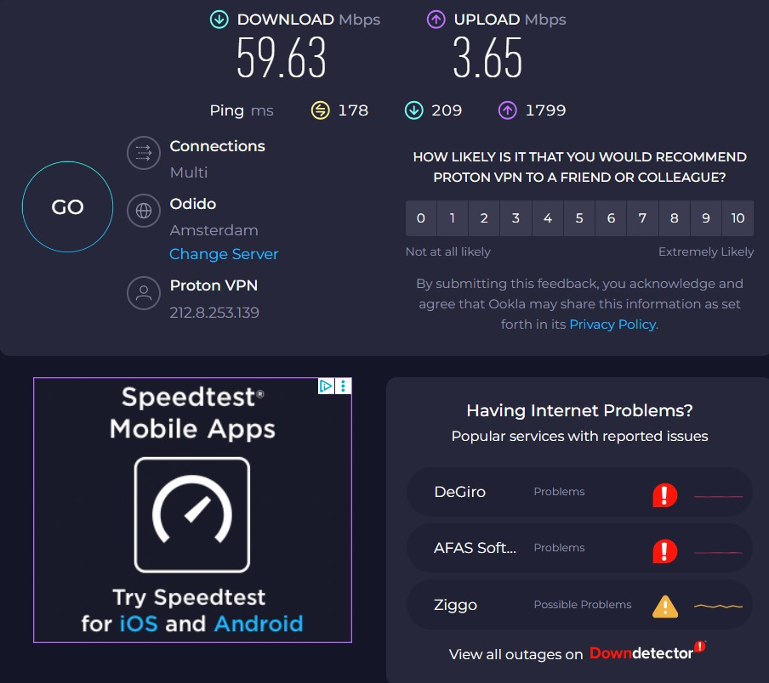

Figure 6: Speed test with VPN

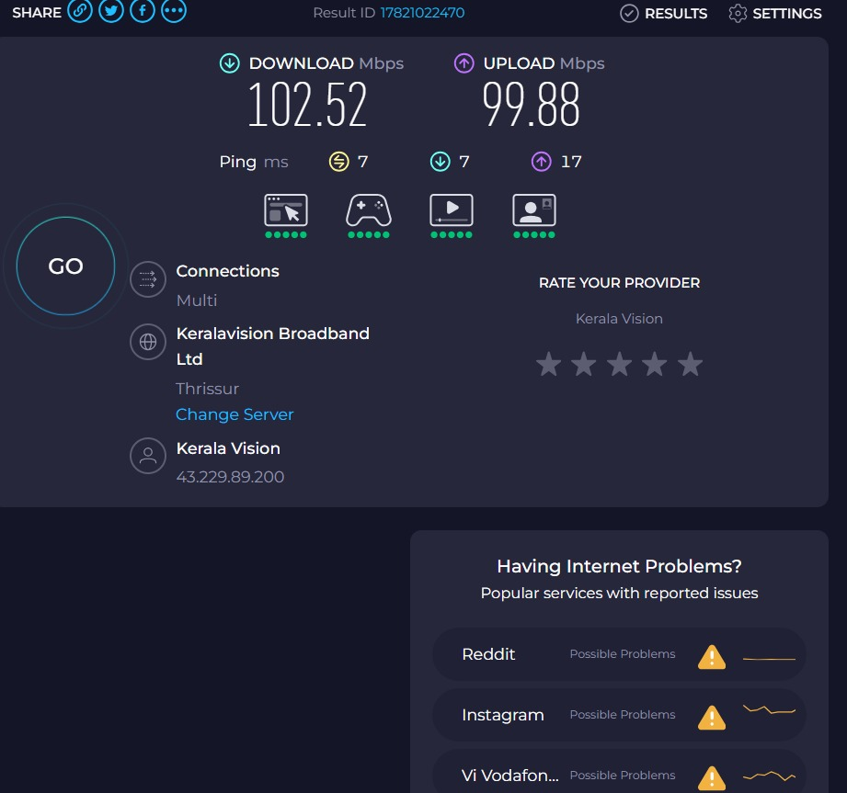

Figure 7:Speed test without VPN

**Analysis**:

* VPNs reduce speeds due to encryption and distant servers.
* Trade-off: **Privacy vs. Performance**.

**5. VPN Encryption & Privacy**

* **Protocols Used**: WireGuard (fast) and OpenVPN (secure).
* **No-Logs Policy**: ProtonVPN is based in Switzerland (strong privacy laws).
* **Limitations**:
  + Free tiers have slower speeds/server limits.
  + Some websites block VPN IPs.

**6. Conclusion**

**Benefits**

* Hides IP address.
* Encrypts traffic on public Wi-Fi.
* Bypasses geo-blocks.

**Limitations**

* Slower speeds (especially upload).
* May trigger CAPTCHAs on websites.

**Final Verdict**:  
ProtonVPN’s free tier is **effective for privacy** but sacrifices speed. Ideal for secure browsing, not high-bandwidth tasks.